Problem 1 – Acceleration Due to Gravity
The function models the time, t, in seconds it takes for any object at rest to fall a distance, d, in meters neglecting air resistance and friction.  Enter this equation next to Y1 in the □ window (with g = 9.81m/s²). Press  and select ZStandard to view the graph. | 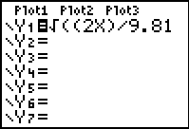  Note: y will replace t and x will replace d.
1. What restrictions should be placed on the function given its real context?

2. Using the graph, press  to determine how much time will elapse for the fall of an object being dropped from a height of 200 m above the ground?

3. Is there a maximum value for this function? Explain your reasoning.

A comparison of acceleration due to gravity for various bodies is provided to the right.  Acceleration due to gravity is provided in m/s².
  Body | Gravity
  Sun | 274.13
  Mercury | 3.59
  Venus | 8.87
  Earth | 9.81
  Moon | 1.62
  Mars | 3.77
  Jupiter | 25.95
  Saturn | 11.08
  Uranus | 10.67
  Neptune | 14.07
  Pluto | 0.42
Go back to the □ screen and again graph . This time let d = 20 meters, and let x replace g. Observe the times required for an object to fall from a height of 20 meters. | 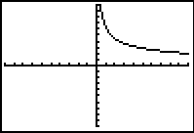
Use  to answer the following questions.
4. On which of the given bodies will the 20 meter fall require the most time?

5. On which of the given bodies will the 20 meter fall require the least time?

6. How much time will the fall of the object from a 20 meter height require on Earth?

Problem 2 – Solution Dilution
Chemists often have to dilute existing solutions to create new solutions using up solutions they have on hand.
5 liters of a 10 molar solution of hydrochloric acid is diluted with x liters of a 2 molar hydrochloric acid solution. This concentration adjustment may be modeled with the equation
M(x) is the concentration in molarity for a solution prepared using 5 L of the 10 molar solution and x Liters of the 2 molar solution.
Enter this equation next to Y1 on □ screen.  Press  and set the Xmin to 0 and the Xmax to 300.  Press  and then press  to help answer the questions below. | 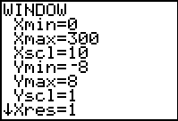
7. Given , what is the highest possible concentration for this situation?

8. What is the lowest possible concentration approached in this situation?

9. Does any part of the graph not make sense in the real context of this problem? If so, explain.

