Activity Overview  This activity is intended to provide students with an opportunity to discover a few interesting properties of an ellipse. The first property students will explore forms the basis of the definition of an ellipse, i.e., the set of all points such that the sum of the distances from these points to two fixed points is constant.  Topic: Conics  - Identify the conics produced by the intersection of various planes with a cone.  - Derive the equation (in rectangular form) of an ellipse as the locus of a point that moves so that its total distance from two fixed points (–f, 0) and (f, 0) is a constant. Then graph the equation.  - Write the equation of an ellipse with center (0, 0) given its vertices and co-vertices and graph it.  Teacher Preparation and Notes  - This investigation could be used as an introduction to the ellipse. Students may have previously explored the other conic sections, although knowledge of these concepts is not required for this activity.  - Only ellipses centered at the origin with their major axes on the x-axis are studied in this activity.  - This activity is designed to be student-centered.  - As an extension to this activity, you may decide to derive the general equation of an ellipse centered at the origin and with the major axis on the x-axis. If the foci are (±c, 0) and b is the y-intercept, then you can use the fact that b² = a² – c² and have the students derive the formula A similar analysis can be used to derive the formula for an ellipse centered at the origin with major axis along the y-axis: .  - To download the student worksheet, go to education.ti.com/exchange and enter “9887” in the keyword search box. | 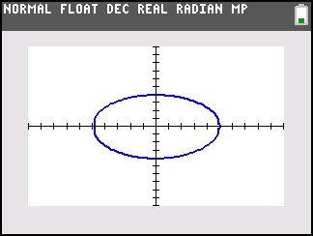  This activity utilizes MathPrintTM functionality and includes screen captures taken from the TI-84 Plus C Silver Edition. It is also appropriate for use with the TI-83 Plus, TI-84 Plus, and TI-84 Plus Silver Edition but slight variances may be found within the directions.  Compatible Devices:  - TI-84 Plus Family  - TI-84 Plus C Silver Edition  Associated Materials:  - PropertiesOfAnEllipse_ Student.pdf  - PropertiesOfAnEllipse_ Student.doc  Click HERE for Graphing Calculator Tutorials.

Introduction
Two focus questions define this activity:
- How can we construct an ellipse on a coordinate plane?
- What interesting properties does an ellipse possess?
Before answering these questions, direct students to the diagram shown on their worksheet. Tell students that conic sections get their name from the intersection of a right circular cone and a plane. If students know about the other conic sections, challenge them to think about ways to orient the plane to produce an intersection that will yield these other conics.

Students need to change the answers from displaying as fractions to decimals. Press , arrow down to ANSWERS, and press  on DEC. | 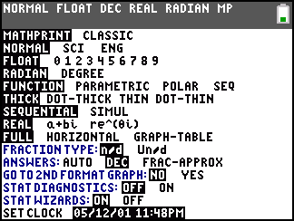
Problem 1 – Investigating the definition of an ellipse
Step 1: It is recommended that students work cooperatively on Problem 1. One student can trace the graph and another student can calculate the distances on the Home screen.  They should note that the sum of the distances remain constant, while the individual lengths continuously change. | 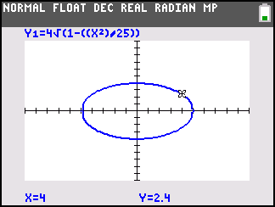
The graphs are automatically set so that Y1 is blue and Y2 is red. Students should change the settings for Y2 to blue, so that they think of the graph as one ellipse.  On the □ screen, arrow to the right of Y2 and press . Use the left and right arrow keys to select BLUE. Arrow down to OK and press . | 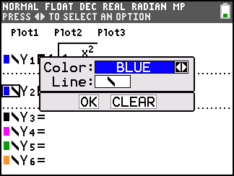
Step 2: From their observations, students are asked to write the definition of an ellipse, in their own words. This definition should closely resemble the definition below:  An ellipse is the locus of points on a plane where the sum of the distances from any point on the curve to two fixed points is constant. The two fixed points are called foci (plural of focus).  Check student responses to ensure their definitions are mathematically correct. Provide clarification as needed. | 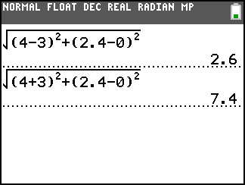
Problem 2 – An interesting property of an ellipse
Step 1: This problem is intended to show students that the foci of an ellipse are equidistant from the center (in this case, the origin) and lie on the major axis (here, the x-axis).
Step 2: Students are also asked to examine the reflective properties of an ellipse. The image to the right demonstrates that a tangent to the ellipse at point P can be used to construct the rays that enter and leave point P. This should help students see that the outgoing ray is a reflection of the incoming ray. By observing this effect, students should recognize that any ray leaving one focus is reflected off the ellipse and directed to pass through the second focus.
Problem 3 – Another interesting property of an ellipse
Step 1: Students will observe that the position of the foci affects the shape of the ellipse. The screenshot to the right shows that the ellipse becomes narrower (or flattens out) as the foci are moved away from one another.  The next screenshot shows the opposite—that ellipse becomes more circular when the foci are moved towards one another. | 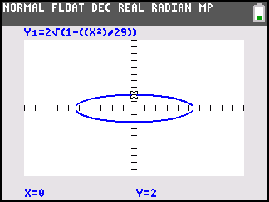
Step 2: When the foci coincide, the ellipse is actually a circle. Students should note that the definition of the ellipse still holds and therefore this shape is still an ellipse. Furthermore, students should understand that the circle is actually a special case of the ellipse.  These observations are related to the eccentricity of an ellipse, given by the formula , where c is the absolute value of the x-coordinate of the foci and a is the absolute value of the x-intercepts of the ellipse. This is a concept that you may wish to have students explore as an extension to this activity. | 