About the Lesson  This activity allows students to use an interactive, investigative approach to determining the sum of the interior angles of a quadrilateral. Students will use the CabriTM Jr. application to draw, measure, and calculate as they explore the angles of quadrilaterals. As a result, students will:  - Deduce that the sum of the interior angles of a quadrilateral is 360° [(n – 2) × 180°, when n = number of sides of the polygon].  Vocabulary  - polygon  - quadrilateral  - interior angle  Teacher Preparation and Notes  - This activity is designed for a high school geometry classroom. It assumes previous knowledge of the definition of a polygon as well as polygon classifications by number of sides (e.g., pentagon, hexagon, n-gon).  - Before beginning this activity, make sure that all students have the Cabri Jr. application installed.  Activity Materials  - Compatible TI Technologies:  TI-84 Plus*  TI-84 Plus Silver Edition*  TI-84 Plus C Silver Edition  TI-84 Plus CE  * with the latest operating system (2.55MP) featuring MathPrint TM functionality. | 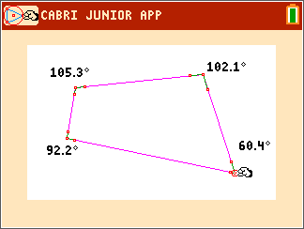  Tech Tips:  - This activity includes screen captures taken from the TI-84 Plus CE. It is also appropriate for use with the rest of the TI-84 Plus family. Slight variations to these directions may be required if using other calculator models.  - Watch for additional Tech Tips throughout the activity for the specific technology you are using.  - Access free tutorials at http://education.ti.com/calculators/pd/US/Online-Learning/Tutorials  - Any required calculator files can be distributed to students via handheld-to-handheld transfer.  Lesson Files:  - Measuring_Angles_in_a_ Quadrilateral_Student.pdf  - Measuring_Angles_in_a_ Quadrilateral_Student.doc

Students will begin by opening a new CabriTM Jr. file and constructing a quadrilateral. To construct a quadrilateral, students should press p and select Quad. They should move the cursor to the point they want to place the first vertex and press Í to drop the point. Students drop the remaining three vertices. Pressing ‘ will allow them to exit the quadrilateral drawing tool. | 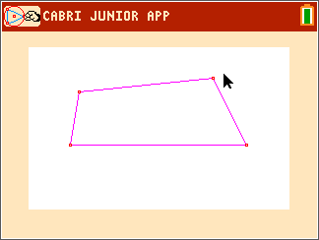
Next, students will measure the interior angles of their quadrilateral. They will use the Angle Measurement tool (press s, then select Measure > Angle). Directions are given for displaying the angle measure rounded to the nearest tenth. | 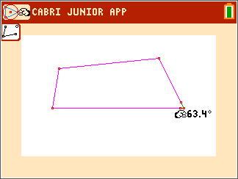
Students will need to find the sum of the measures of the interior angles. Students are not able to use the Calculate tool, as the Calculate tool only allows the sum of at most 3 numbers. Students should find that the sum of their interior angles is equal to 360°.  Note: Sometimes there may be a rounding error in the angle measures and the sum may not be exactly 360°. This is a limitation of the software.  1. Sketch your quadrilateral below. Record the interior angle measurements.  Sample Answer: See screen to the right.  2. Find the sum of the angles.  Answer: 360° | 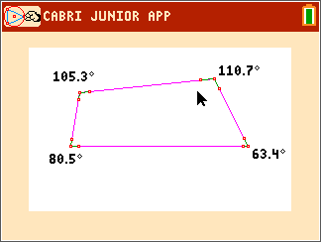
Students will move one of the vertices to another location. They can grab the vertex by pressing ƒ, then move the vertex using the arrow keys, and place it by pressing ƒ or ‘. Students should add up the interior angles again, and find that the sum will always be 360°.

3. Record the measures of the four angles after moving a vertex. Find the sum of the angles.

Sample Answers: 105.3°, 102.1°, 60.4°, 92.2°; 360°

4. Record the measures of the four angles. Find the sum of the angles.

Answers: 101.6°, 102.1°, 71.7°, 84.6°; 360°

5. Make a conjecture: The sum of the interior angles of a quadrilateral is _____.

Answer: 360°

