Science Objectives  - Students will observe the interaction between an enzyme and its substrate.  - Students will observe the effect that enzymes have on chemical reactions.  - Students will explore the effects of temperature and substrate concentration on enzymatic reactions.  Vocabulary  - anabolic  - catabolic  - catalase  - enzyme  - hydrogen peroxide  - metabolism  - substrate  About the Lesson  - This lesson investigates the properties of enzymes and how they affect reaction rates.  - As a result, students will:  - Understand how enzymes interact with their substrates.  - Observe the effect of enzymes on the activation energy of chemical reactions.  - Observe the effect of temperature and substrate concentration on enzymatic reaction rates.  TI-Nspire™ Navigator™  - Send out the Need_for_Speed.tns file.  - Monitor student progress using Screen Capture.  - Use Live Presenter to spotlight student answers.  - Enter items as appropriate for use of TI-Nspire Navigator.  Activity Materials  - Need_for_Speeed.tns document  - TI-Nspire™ Technology | 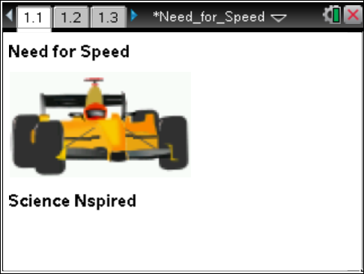  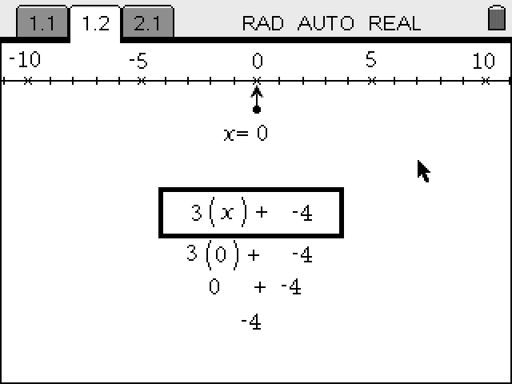  TI-Nspire™ Technology Skills:  - Download a TI-Nspire document  - Open a document  - Move between pages  - Use a minimized slider  - Select axes labels on a graph  Tech Tips:  Make sure that students know how to perform a linear regression.  Lesson Materials:  Student Activity  - Need_for_Speed_Student.  doc  - Need_for_Speed_Student.  pdf  TI-Nspire document  - Need_for_Speed.tns

Discussion Points and Possible Answers

Move to page 1.2.  1. The play and reset buttons in the upper left corner stop and start the animation. The students will start the animation by clicking on the .  Note: Be sure your students Pause the animation before they move to the next page. ( ) | 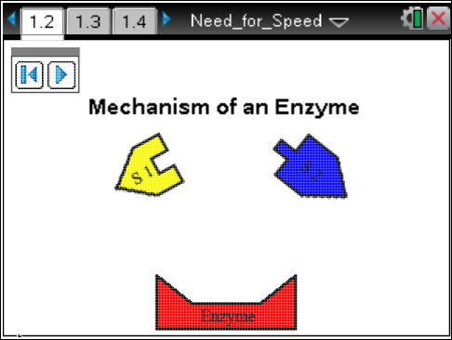
Tech Tip: Inform students that the animation on page 1.2 must be paused before moving on. This will be critical when they get to the animation on page 1.7.
Move to pages 1.3 and 1.4.
Have students answer the questions on either the handheld, on the activity sheet, or both.
Q1. The simulation on the previous page represents a catabolic reaction. True or False?

Answer: False

Q2. What is the name of the region on the enzyme where the reaction took place?

Answer: active site

Move to page 1.5.  2. Directions are given for the next simulation. The purpose of this animation is to demonstrate how enzymes LOWER the activation energy of a reaction. | 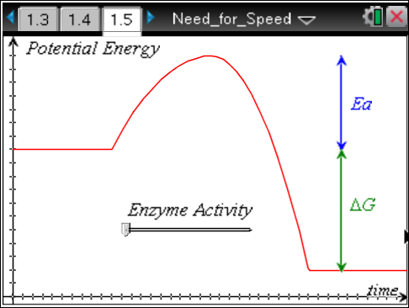
Move to page 1.6.
Have students answer the questions on either the handheld, on the activity sheet, or both.
Q3. Which of the following changes with the use of an enzyme?

Answer: A. activation energy, E_{a}

Move to page 1.7.  3. Directions are given for the next simulation.  The purpose of this simulation is to model the effect that temperature has on enzyme activity.  Students should start with a temperature of 35°C and click on the play button (). The simulation at different times will take longer to run. Students will need to wait for this process to complete.  When the simulation is complete, students advance to page 1.8. | 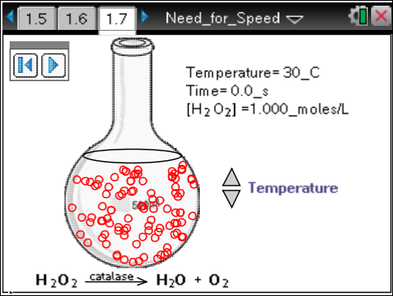
Tech Tip: The second time they run the simulation on page 1.7, students can move to page 1.8 to watch as the data is plotted. Or they can move back to page 1.7 and watch the simulation.
Move to page 1.8.  4. The first time the simulation is run, students need to choose concentration as the correct variable for the y-axis. The graph of the simulated reaction will appear. | 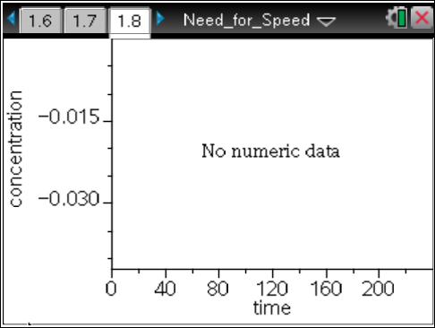
Have students answer the questions on either the handheld, on the activity sheet, or both.
Q4. Describe the relationship between substrate concentration and time that occurs during an enzymatic reaction.

Answer: At the beginning, there is a steep decline because there is a large concentration of substrate. Therefore, there are multiple interactions between substrate and enzyme. As the substrate is used up, the reaction slows down because there are fewer molecules for the enzyme to encounter.

Check for Understanding:
There is a common misconception that the enzyme is being used up! Discuss with your students how detrimental it would be if an organism constantly needed to replenish enzyme concentrations.

Move to page 1.9.  5. Students will label column A time and column B concentration. They will label column C lnc (which stands for natural log of concentration). They will press natural log (/ u) in the equation box and type b in the ( ).  Even if your students have not studied natural logs, this will teach them how a linear representation can be generated in order to determine slope (which is the rate of the reaction). | 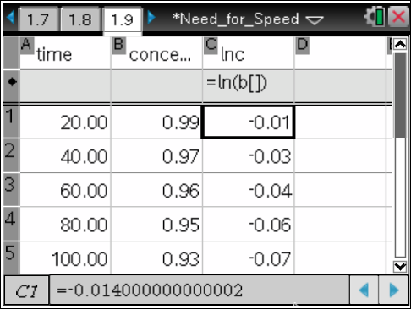

TI-Nspire Navigator Opportunities
Select a student to be the live presenter to demonstrate how to label the columns and insert the formula for Column C. This may help ensure that all students accomplish this correctly.

Move to page 1.10.  6. Here students will graph lnc versus time. This will generate a line that students will analyze to determine the rate of the simulated reaction. Students will perform a linear regression on this graph by pressing Menu > Analyze > Regression > Show Linear (mx+b). | 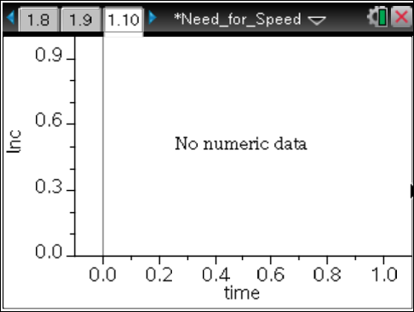
They will then record the temperature and the slope (reaction rate) for that temperature in the table below.
Note: The purpose of this step is to reinforce the relationship between temperature and rate of enzymatic reactions.
Students will return to page 1.7 and click on the reset button ().
7. Students choose a different temperature and then click on the play button. () Students then will advance to page 1.8.
Once the animation is completed, students will advance to page 1.10 and record the slope of the lnc curve for the new temperature. They will repeat this step three more times to obtain data for five different temperatures.
 | RESULTS
 | Temperature (°C) | Slope of lnc Curve (Reaction Rate)
1. | 10°C | -0.000175 molecules/sec
2. | 20°C | -0.00035 molecule/sec
3. | 30°C | -0.0007 molecules/sec
4. | 40°C | -0.0014 molecule/sec
5. | 50°C | -0.0028 molecule/sec

Q5. Analyze the data in the chart. Describe the pattern illustrated by the data.

Answer: As the students record the data for the five different temperatures, they will see the pattern that for every 10° C increase in temperature, the reaction rate doubles. This is called a Q₁₀ relationship, and commonly occurs in many other situations. For example, when Daphnia are exposed to different temperatures and heart rate is recorded, the same Q₁₀ relationship is observed.

Wrap Up
When students are finished with the activity, pull back the .tns file using TI-Nspire Navigator. Save grades to Portfolio. Discuss activity questions using Slide Show.

Assessment
- Formative assessment will consist of questions embedded in the .tns file. The questions will be graded when the .tns file is retrieved. The Slide Show will be utilized to give students immediate feedback on their assessment.
- Summative assessment will consist of questions/problems on the chapter test.

