Airport Impact Study  ID: 9319 | Time required  45 minutes

Activity Overview
This activity is based on an impact study to address the concerns of the residents of a community near an airport. Students use a table of sound readings to develop an inverse variation model. After verifying the model, students use it to map safe and unsafe zones based on sound-intensity restrictions.

Topic: Rational & Radical Functions & Equations
- inverse variation
- direct variation

Teacher Preparation
- Prior to beginning this activity, students should have had experience with direct variation problems. This activity could be used as an introduction to indirect variation, although some experience with indirect variation is preferred.
- This activity requires students to graph functions, plot data in scatter plots, and use simple formulas with lists. If students have not had experience with these functions of the calculator, extra time should be taken to explain them.
- To download the student worksheet, go to education.ti.com/exchange and enter “9319” in the quick search box.

Associated Materials
- Alg2Week09_AirportImpact_worksheet_TI84.doc

Suggested Related Activities
To download any activity listed, go to education.ti.com/exchange and enter the number in the quick search box.
- Constant of Variation (TI-84 Plus family) — 11196
- Direct, Inverse, and Joint Variation (TI-Navigator) — 1895
- Inverse Variation (TI-84 Plus family) — 8203

Before beginning the activity, have students clear all lists by pressing ` ´ and selecting ClrAllLists.  Then have them turn off all equations in the Y= screen by pressing ` ≠ and selecting FnOff. | 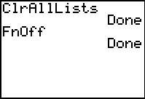

Problem 1 – Creating a model
Residents of a town near an airport are concerned that the noise levels in their community are not safe. They have hired you to perform an impact study to address their concerns. You will develop a model of the intensity of the noise is different areas surrounding the airport and use it to map safe and unsafe zones.
The table shows sound readings collected at various distances from the center airport (the source of the noise). Distance is entered in L₁ and Sound Intensity is entered in L₂. | 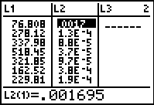
Students will then create a scatter plot of Intensity vs. Distance (L₂ vs. L₁).  On the worksheet they are given the equation for how two variables vary inversely.  yx = k and yx² = k | 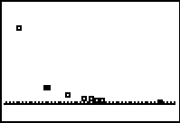
On the Home screen, students will calculate (distance)² stored in L₃ and intensity*(distance)² stored in L₄. This will produce two lists, which can be seen in the List Editor.  Due to the rounding of the values in the table, the values in list L₄ will be close to 10, but not exactly 10. Students should use 10 as their constant of variation when developing their function I(d). | 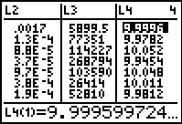
Students are to then enter their function in Y₁ (Y₁ = 10/x²) The graph of the function should pass through the scatter plot of the data points. | 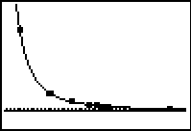

Problem 2 – Applying the model
The community association has defined of 3 noise-level zones.
Zone 1: Intensity < 0.000001 W/m².
Zone 2: 0.000001 < Intensity < 0.0001 W/m².
Zone 3: Intensity > 0.0001 W/m².
Students will use their function to write and solve for the boundaries of each zone.  Then they can draw a map labeling the noise source and zones with the distances. | 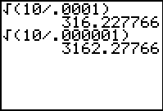

Solutions
1. The square of the distance times the intensity is the same number for each row.
2. 10
3.
4. Unsafe zone: zone 3; Impact zone: zone 2; Safe zone: zone 1
5. Each zone will be circular with a center at the noise source.
6. distance = 3162 meters
7.
8. distance = 316 meters
9. See the next page.

zone 3
zone 2
zone 1
316 m
3162 m
noise source

