Open the TI-Nspire document When_Water_Leaves.tns.  You have always known that plants needed water. When a plant goes only a few days without water, it starts to look pretty bad. What factors influence how quickly plants lose water? This will be explored during this activity. | 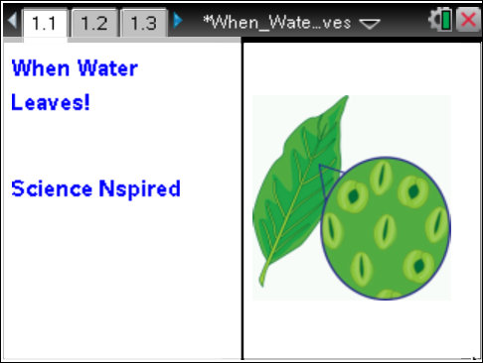

Water is one of the reactants in the photosynthetic process, and it maintains the turgor pressure (pressure against cell walls) in plant cells. This outward pressure keeps the leaves of the plant from drooping. Droopy leaves display less surface area to the sun, thereby reducing photosynthesis. This causes the plant to produce fewer nutrients.
Plants take in water through their roots, and the water travels through the plant to the leaves. The water that is not used for either photosynthesis or maintaining turgor pressure is released from the leaves. In fact, most of the water that a plant takes in is never used by the plant. And the amount of water that leaves the plant is staggering. A 50 foot tall maple tree loses about 60 gallons of water per hour from the surfaces of its leaves.
Transpiration is the process of water escaping from leaves through pores called stomata. Stomata also allow for gas exchange (CO₂ and O₂) for the plant. A number of environmental factors affect transpiration rate, such as temperature, relative humidity, and wind. In the simulation in this activity, you will be able to manipulate these environmental factors and see what effect they have on transpiration rates.

Move to pages 1.2–1.4.

After reading the background information on page 1.2, move to page 1.3. Page 1.3 shows a picture of a leaf, along with some environmental conditions that you will eventually manipulate.  1. For the first simulation, leave the conditions as they are and click on the start arrow . The simulation takes a couple of minutes to run to completion. While the simulation is running on page 1.3, periodically move to 1.4 so you can see both the diagrammatic and graphical representations. When the simulation is finished, a graph with four plots will display patterns for you to analyze. | 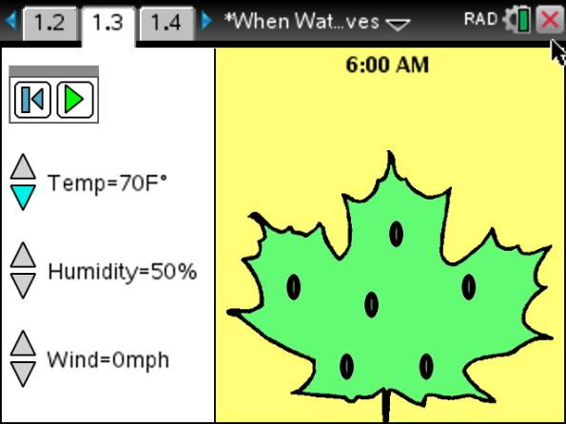
Answer the following questions (Q1- Q7) here.
Q1. In the graph space to the right, sketch and label the four plots.

Q2. Why did the “peaks” in the temperature and transpiration plots occur at nearly the same time?

Q3. Predict how the graph would change if you increased the temperature.

Q4. Predict how the graph would change if you decreased the temperature.

Q5. Does the transpiration rate change when the temperature changes? Explain.

2. Reset the animation on page 1.3 by clicking on the  icon. Run the simulation two more times—one with the temperature set at 90ºF and the other with the temperature set at 50ºF. To adjust the temperatures, click on the up and down arrows next to the “Temp” control.
3. Sketch the graphs below.

Q6. Graph at 90ºF. | Q7. Graph at 50ºF.

4. Now you may change the environmental conditions in any ways you would like. Run the simulation at least four more times, record the conditions, and then sketch your resulting graphs.

Simulation 1:  Temp: ______ Humidity: ______ Wind: ______  Graph: | Simulation 2:  Temp: ______ Humidity: ______ Wind: ______  Graph:
Simulation 3:  Temp: ______ Humidity: ______ Wind: ______  Graph: | Simulation 4:  Temp: ______ Humidity: ______ Wind: ______  Graph:
Analysis Questions
Move to page 2.1-2.5.
Answer the following questions here or in the .tns file.
Q8. Which one of the following is true?
A. Plants make use of almost all of the water they take in.  B. Most of the water that a plant takes in is released through the leaves. | C. Water and oxygen are the two reactants in the process of photosynthesis.  D. Transpiration happens through the roots.
Q9. Water actually leaves the plant through small pores called ________________________.

Q10. Select all of the following that would increase the rate of transpiration. (More than one response may be correct.)
A. high humidity  B. strong winds  C. cool temperatures | D. low humidity  E. hot temperatures
Q11. What process in humans is most similar to transpiration in plants?

Q12. Which of the following could result if a plant does not have enough water? Choose all that would be correct. (More than one response may be correct.)
A. Photosynthesis rates would decrease.  B. Carbon dioxide usage would increase. | C. All of the stomata would open and stay open.  D. Turgor pressure in leaf cells would decrease.
Answer the following questions here.
Q13. Describe how the environmental temperature affects the rate of transpiration.

Q14. Describe how relative humidity affects the rate of transpiration.

Q15. Describe how wind affects the rate of transpiration.

Q16. Describe the weather conditions on a day when transpiration rates would most likely be high.

Q17. Describe the weather conditions on a day when transpiration rates would most likely be low.

Q18. How do you think plants regulate the rate of transpiration?

Q19. Describe how wind affects the rate of transpiration.

Q20. What structural adaptations do you think desert plants have to reduce transpiration? Explain how these adaptations reduce transpiration.

Q21. Describe a terrestrial environment in which plants might have really large leaves with lots of stomata.

Q22. Water regulation is critical for all animals and plants—including humans. Perspiring is one means by which humans regulate water for our bodies. How are perspiring and transpiration similar? How are they different?

