Part 1 – Move Those x’s
Press S and select 1:Edit… to enter the numbers shown at the right. Use the arrow keys to move from one list to another.  List L1 represents the x-values.  List L2 represents the y-values. |  | 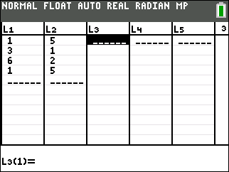
Press ` å and select Plot1. Match the settings as shown at the right.  Press # and select ZStandard to view the graph.  Press ` å again and select Plot2. Use the same settings as Plot1, but for Xlist select L3 and for Ylist select L4 and leave the Color in Plot2 RED. |  | 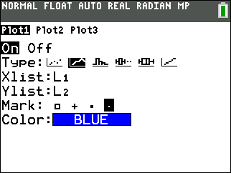
Press ` î to return to the home screen. For Exercises 1 and 2, enter both expressions and then press %. Sketch the graph. To enter the arrow, press =. Note: To enter the names of the lists (L1, L2, L3, L4), press ` ò and select the appropriate name.
1. L1 + 3 → L3  L2 → L4  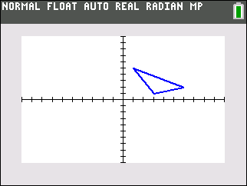 | 2. L1 – 3 → L3  L2 → L4
3. How did the x-values change?

4. How did the triangle move?

5. What happens when a number is added to or subtracted from the x-values of a figure?

Part 2 – Move Those y’s
Return to the home screen. For Exercises 6 and 7, enter both expressions and then press %. Sketch the graph.
6. L1 → L3  L2 + 5 → L4 | 7. L1 → L3  L2 – 5 → L4
8. How did the y-values change?
9. How did the triangle move?
10. What happens when a number is added to or subtracted from the y-values of a figure?

Part 3 – Change That Shape
Return to the home screen. For Exercises 11 and 12, enter both expressions and then press %. Sketch the graph.
11. 2 ∗ L1 → L3  2 ∗ L2 → L4 | 12. ∗ L1 → L3  ∗ L2 → L4
13. How did the x-values and the y-values change?

14. How did the triangle change?

15. What happens when a number between 0 and 1 or greater than 1 is multiplied by the x- and y-values of a figure?

