Open the TI-Nspire document How_Does_a_Spring_Scale_Work.tns.  In this simulation, you will gather data to determine how a spring scale measures weight based on the spring’s stretch. Then you will analyze the data to determine the strength of the spring. | 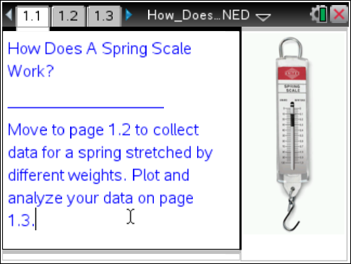
The spring scale is simply a spring fixed at one end and with a hook at the other end on which to attach an object. When weight is added to the hook, the spring stretches from its rest position.
- The distance the spring is extended from its rest position, called the spring’s stretch, is proportional to the loaded weight.
- The strength of the spring is determined by how much weight (in lbs) is needed to stretch the spring by a length of 1 ft. This quantity, called spring constant, is measured in lbs/ft.
Thus, when we know the stretch and the strength of the spring, we can find the weight of the load.

Move to page 1.2.

1. We will stretch the simulated spring from its original length by loading different weights. Select the up arrow to add weight to the spring.
a. Record the measured weight for each given spring’s stretch in the second column of the table below.

Stretch (s), ft | Weight (w), lbs | Ratio, , lbs/ft
ft
ft
ft
ft

2. What do you observe as you add weight to the spring?

3. If the stretch doubles, what happens to the weight? Give two examples to support your conclusion.

4. Enter your data into the Lists & Spreadsheet on Page 1.2.

5. Return to the table on the previous page of this worksheet. Simplify the ratio of the weight (w) to the stretch (s) for each entry in the table in order to determine unit rate. Record the ratios in the third column and show your calculations.

6. What are your observations about these unit rates?

7. Is there a relationship between the stretch of the spring and the loaded weight? If so, explain what it is, and why you think it exists.

Move to page 1.3.

8. Describe what the scatter plot on this page represents.

9. What are some of the interesting features of the scatter plot?

10. Select the “show line” arrow to display the line of best fit and an equation that models the relationship between the weight on the spring and the stretch of the spring. What observations can you make?

11. a. What is the unit rate for any given weight to the spring’s stretch ? What evidence do you have for this?

b. What is the slope of the line that goes through the points? On what are you basing your response?

c. What do you notice about the unit rate and the slope? What does it tell you?

12. Explain why the line begins at the origin rather than going through the origin.

13. a. Using your findings, determine the strength of the spring scale (the spring constant). Indicate units of measurements.

b. Write a summary statement comparing the strength of the spring scale to the unit rate of change and comparing the strength of the spring scale to the slope of the line.

