Open the TI-Nspire document Tables_Graphs_Equations.tns.  In this activity, you will explore the relationship between two variables presented by a table, equation, and a graph of a line. You will have the opportunity to change the relationship and test it for proportionality. | 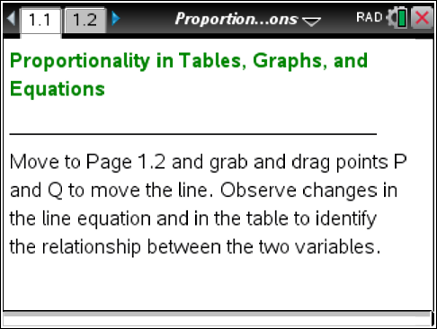

Move to page 1.2.

1. Grab and drag point Q. Notice the table of values for the coordinates of the points that lie on a line.
a. What stays the same, and what changes as the line moves?

2. Grab and drag point Q until you see the equation y = 5x.
a. Select three points (excluding the origin) from the table, and find the ratio of the y-coordinate to the x-coordinate for each point.
b. In the table below, record your chosen points and their ratios.
x | y

3. What do you notice about the values in the column?

4. Compare the values of the ratios with the equation of a line. What do you notice?

5. Why was it necessary to exclude the origin when calculating the ratio?

6. Grab and drag point Q to plot a line with a different equation. Record the equation of this line below.

- Select three points from the table of values, and find the ratio of the y-coordinate to the x-coordinate for each point. Record your results in the table below:
Equation of the line:
x | y

8. What do you notice about the values in the column?

9. Compare the values of the ratios with the equation of the line. What do you notice?

10. Based on your observations and computations, what stays the same for each line?

11. Drag point P away from the origin along the y-axis, and select a new location for it. Record the equation of this line below.

12. Select three points on this new line, and find the ratio of the y-coordinate to the x-coordinate for each point.
Equation of the line:
x | y

13. What do you notice about the values in the column?

14. What stays the same for each given line when P is not at the origin?

15. Is y proportional to x? Justify your answer.

16. Compare the ratios on the lines running through the origin and the ratios on the line that does not run through the origin.
a. In which case are the coordinates proportional to each other?

b. Why?

