Open the TI-Nspire document Add_Sub_Rational_Numbers_Part2.tns.  In this activity, you will represent addition and subtraction of positive and negative mixed numbers on a horizontal number line. | 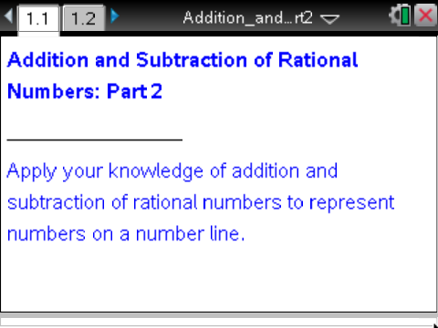

Move to page 1.2.

Page 1.2 shows a number line with two movable points:
- represented by a solid vector, and
- represented by a dotted vector.

The sum (or difference) of and is modeled using vectors above the number line:
- The red vector pointing to the right will always represent a positive number.
- The blue vector pointing to the left will always represent a negative number.
- The vertical solid line represents a target sum or difference ().
- As you manipulate the values of and , the actual value of the sum (or difference) is represented by a vertical dotted line that goes through the corresponding point on the number line.

Tech Tip: You can select a new target value by clicking on the left or right arrows below the label New. You can change the operation from addition to subtraction by clicking on the Operation arrows — left arrow for subtraction and right arrow for addition. After using either of the arrows, press d in order to be able to grab and drag the points.

Tech Tip: Students can select a new target value by tapping on the left or right arrows below the label New. You can change the operation from addition to subtraction by tapping on the Operation arrows — left arrow for subtraction and right arrow for addition. To drag the points for a or b, touch the point and drag your finger while still touching the iPad.

1. For each case listed in the table on the next page, you are given a value for point and a value for . Using the interactive number line model on Page 1.2, grab and drag point to the given value on the number line.

2. Then, calculate the value of , so that the sum (or difference) of and is equal to the target value . Record your answers and calculations in the provided table on the next page:
- Compute , and show your work.
- Draw a number line representation of the problem with given values of and , and mark the value of on the number line.
- Write an inequality that represents relationships between values , , , and zero.

3. Check your calculations by moving point to the location on the number line that you found. Does the actual sum equal the target sum (does the vertical dotted line match the vertical solid line)? What does it mean that the actual sum is equal to the target sum?

 | Case | - Number line representation. | - Calculations. | - Inequality
1) |  | 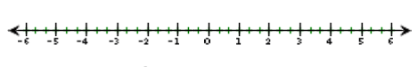
 | Case | - Number line representation. | - Calculations. | - Inequality
2)
 | Case | - Number line representation. | - Calculations. | - Inequality
3)

 | Case | - Number line representation. | - Calculations. | - Inequality
4)
 | Case | - Number line representation. | - Calculations. | - Inequality
5)
 | Case | - Number line representation. | - Calculations. | - Inequality
6)

4. On Page 1.2, select Operation to select addition. Select New until the Target value is negative. Be patient. This might take several selections. Record this value .

- Choose the value of so that . Record this value,. Calculate the value of , and locate its position on the number line.

- Choose the value of so that . Record this value,. Calculate the value of , and locate its position on the number line.

- Choose the value of so that . Record this value,. Calculate the value of , and locate its position on the number line.

5. Select Operation to select subtraction. Select New until the Target value is negative. Be patient. This might take several selections. Record this value .

  - Choose the value of so that . Record this value,. Calculate the value of , and locate its position on the number line.

  - Choose the value of so that . Record this value,. Calculate the value of , and locate its position on the number line.

  - Choose the value of so that . Record this value,. Calculate the value of , and locate its position on the number line.

6. Refer to the number line on Page 1.2 to complete the Addition and Subtraction of Mixed Numbers – Summary Chart.

Explain your results for each case in the chart.

