Introduction
Have you ever stopped to think about how much stuff you throw away every day? Probably not! As our population grows, the amount of trash that we produce also grows. Are we ready to handle such an increase? This is something that we need to think about and plan for!
How much garbage do people produce each year? Does the amount change as the population changes? The data table below shows a comparison between population and the amount of garbage produced for the years 1960 through 1995. The data reflect the amount of garbage produced in the United States as the population of the United States has grown. Observe patterns in the data. When did garbage production slow down? When did it speed up? Make predictions about garbage collection for the years 2000 and 2005.
Year | Garbage (billions of kg per year) | Population  (in millions)
1960 | 81 | 179
1965 | 99 | 190
1970 | 117 | 203
1975 | 122 | 214
1980 | 132 | 227
1985 | 145 | 238
1990 | 180 | 249
1995 | 208 | 262

Objectives
In this activity, you will:
- examine data about garbage production, observe comparisons in the data, make predictions based on the data.
- sketch a graph based on your predictions.
- design a plan to help deal with potential garbage problems.

You’ll Need
- TI-84 Plus CE calculator
Entering the Data
- Before entering data in the lists, clear any existing data from the lists.
  - Press y L.
  - Highlight 4:ClrAllLists, and then press Í.
  - This takes you to the Home screen, and you will see 4:ClrAllLists with a blinking cursor following it. Press Í, and the TI-84 PLUS CE displays Done. Your lists are now cleared.

- Press … then press Í to choose 1:Edit.
- Enter the Years from the data table in L1, starting with 1960 and ending with 1995.
- Your cursor should be highlighting the first row in L1. Press 1 9 6 0 and then press Í. Notice the cursor is now in the second row of L1.
- Enter the next number, and then press Í. Repeat this process until you have entered all of the data from the Year column.
- Press ~. The cursor should now be highlighting the first row in L2. Enter the data from the Garbage column in L2.
- Press ~ to move to L3. Enter the data from the Population column in L3.
- Make sure you have the same number of entries in all three lists, and that they all align as they do in the data table on page 1. | 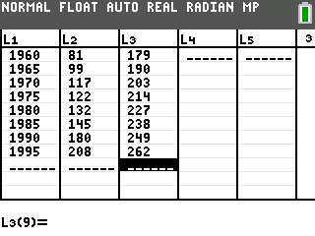
- Make a numerical comparison between the data in L1 and the data in L2.
- Answer question 1 on the Data Analysis page.
- Make a graph of garbage production versus year.  - Press y ,, to access the STAT PLOTS menu. (STAT PLOT is above the o key on the TI-84). The STAT PLOTS menu allows you to choose what type of graph is best for your data.  - Press Í to select 1:Plot1. Set your TI-84 Plus CE as shown at the right. Follow the steps below for more help in setting the calculator up: | 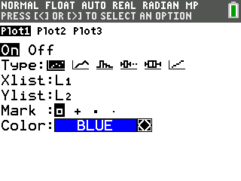
- The cursor will be flashing on the word On. To turn this plot on, press Í.
- Press † to move to Type. The cursor will be flashing on the first option. This is a scatter plot. A scatter plot allows you to plot the independent variable versus the dependent variable. To choose this option, press Í.
- Press † to move to Xlist. The Xlist can also be referred to as the independent variable. If L1 is not in your Xlist, enter L1 by pressing y d. (dis above the À key on the TI-84 PLUS CE).
- Press † to move to Ylist. The Ylist can also be referred to as the dependent variable. Enter L2 for the Ylist by pressing y e.
- Press † to move to Mark. The mark is the type of mark you want to represent each data point on your graph. There are not many data points for this graph, so choose the first option, since it is larger. Your cursor should be blinking on this option. To choose it, press Í.
- Press † to move to Color and select the color of your marks by pressing ~or |.
- Answer question 2 on the Data Analysis page.
- Set the WINDOW appropriate for your data. You are telling the TI-84 Plus CE how you want the graph scaled so that you can best view the data.  - Press p. (p is along the top row of keys on the TI-84).  - Press † to select the settings, and set the window as shown at the right. These settings are appropriate for the garbage collection data. | 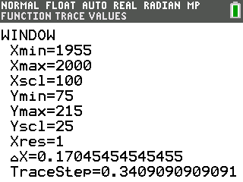
- Press s to see how your data is plotted. Label the axes on the graph at the right. | 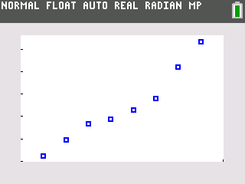
- Press r. Using | and ~, move the cursor from point to point. Notice that the ordered pairs (data points) are shown at the bottom of the screen. Find the two consecutive points where there was the least increase in garbage production. Find the two consecutive points where there was the greatest increase in garbage production.
- Answer question 3 on the Data Analysis page.

- Graph garbage production versus population. Before you do this, decide which will be your independent variable, and which will be your dependent variable.
- Answer question 4 on the Data Analysis page.
- Press y ,, to access the STAT PLOTS menu. Make the necessary changes, keeping in mind your choices for independent and dependent variables.

- Reset your window to make it appropriate for your new data.
- Complete the table under question 5 on the Data Analysis page, indicating what you chose for your window settings.
- Press s.
- Complete the graph in question 6 on the Data Analysis page.
- Press r. Press ~ a few times to move the cursor to the last plotted point on your graph. Make note of the ordered pair.
- Answer question 7 on the Data Analysis page.
- Using this final data point, calculate the amount of garbage generated per person during that year.
- Answer question 8 on the Data Analysis page.
- Assume the rate of garbage production is the same today as it was in 1995.
- Answer question 9 on the Data Analysis page.

Data Analysis
1. a. What number pattern do you observe in L1? Explain.

- What number pattern do you observe in L2? Explain.

2. a. Why are you using the years as the independent variable (Xlist)?

b. Why are you using the garbage production as the dependent variable (Ylist)?

3. a. Between which years did the rate of garbage production slow down?

b. Between which years did the rate of garbage production speed up the most?

- From your graph, predict what the garbage production would be in the years 2000 and 2005. Be sure to indicate the units of production.

4. What is the:
- Independent variable:

- Dependent variable:

Explain your reasoning.

5. Complete the table.
Xmin |  | Ymin
Xmax |  | Ymax
Xscl |  | Yscl
Xres | 1

6. Sketch your graph in the grid below.

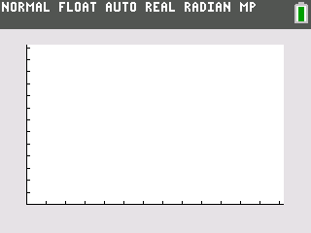
7. What is the ordered pair?
X: Y:
What labels should be applied to each of these numbers?
X: Y:

8. What is the amount of garbage generated per person during the year?

9. How much garbage does your family generate in a day?
A week?
A month?
A year?
How much garbage would your class produce in a year?
How much garbage would your school produce in a year?

Additional Questions for Discussion and Writing
1. What are some potential problems we may be facing now and in the future if the current trend in garbage production continues?

2. Design a plan to help deal with these potential problems.

3. What economic, ecological, and social factors could have attributed to a slowing in the rate of garbage production between 1970 and 1975?

