Applications of Parabolas  ID: 12236 | Time required  20 minutes

Activity Overview
In this activity, students will look for both number patterns and visual shapes that go along with quadratic relationships. Two applications are introduced after some basic patterns in the first two problems.
Topic: Quadratic Functions
- Students will look for number patterns and continue the pattern by adding entries in a spreadsheet format.
- Students will see the shape of the scatter plot generated by ordered pairs that are not linear, but are quadratic parabolas.
- Students will see a quadratic equation graphed over the scatter plot to see that it properly “fits” the data.
- Maximum values, intermediate values, and zeros are introduced as parts of the application problems.

Teacher Preparation and Notes
- Students will utilize the Trace and Calc menu features to find ordered pairs that answer questions about the application problems. Students will find a maximum height, a landing time, and several other heights at various times (for projectile motion problems).
- This activity can be run as a teacher-led activity, with fading prompts for help with the new skills and concepts. A homework problem is provided, as well as extensions for more advanced students, or for a longer period or project.
- To download the student worksheet, go to education.ti.com/exchange and enter “12236” in the quick search box.
Associated Materials
- Alg1Week24_AppsParabolas_Worksheet_TI84.doc
- Boxes.8xi

Suggested Related Activities
To download any activity listed, go to education.ti.com/exchange and enter the number in the quick search box.
- Parabolic Applications (TI-84 Plus) — 6217
- Numb3rs Activities for Algebra Classes (TI-84 Plus) — 9878
- Bridges and Parabolas (TI-84 Plus) — 8096
- McParabola (TI-73 Explorer and TI-Navigator) — 8227

Problem 1 – Number patterns can be revealed in a scatter plot.
First, students are given the ordered pairs to be plotted. To enter the data, press   to access L1 and L2. If needed, move the cursor to the top of the column and press   to remove any old data. Then enter the values. To set up the Stat Plot, press    to access Plot1.  Focus on the y-values and see if you can figure out a mathematical pattern. The students are asked to write an explanation if they can. Some may attempt to explain the – 4, – 3, – 2, … pattern, while others may recognize immediately that the y-values are the “perfect squares”. | 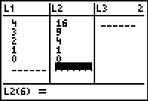
The student will enter in the next three y-values that follow the same pattern. You will need to remind students to scroll down to the empty cells in the L1 and L2 lists. The scatter plot will reveal the new ordered pairs immediately. Now, do they see a visual pattern or shape? What is it? If the numbers entered are not correct, the plotted points will not form a symmetric parabola. Students may rethink their answers and change the data points in L1 and L2. | 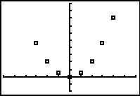
Students are asked to graph y = x². Does the class agree that it matches the data?  Now, the students will use the quadratic function f(x) = x² to predict an unknown term of the pattern, f(7). Press        to evaluate the function for 7. Other values could be entered. | 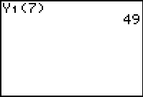
Problem 2 – A pattern that has a visual model with it
Students will draw the next pile on their worksheets. It should add another layer to Pile #3, with a base of 4 bricks across. The total number of bricks in the fourth pile will be 4 + 3 + 2 + 1, or 10.  In L1 and L2, students should enter the number that will continue the pattern. The continuation of the pattern will go 1, 3, 6, 10, 15.  If you would like to recreate the image, Boxes.8xi has been provided as a Pic that can be loaded on your calculator or students’ calculators. | 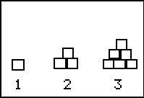

Problem 3 – A pancake in the air? An application of a parabola at breakfast time!
It is important to note that this equation is written with the units in meters and seconds. Therefore, the initial height (0.45 m) means that the spatula with the pancake is 45 cm above the griddle surface. Times are still in seconds, but the pancake rises only 1.07 m (107 cm) per second, and will not be in the air for very long! | 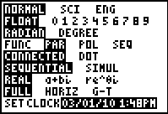
If you would like to graph the “pancake” going up and down (like its actual movement), you will need to use parametric equations. Student directions are given in Function mode only. | 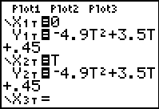
Look at how the pancake rises slightly before it falls and lands on the griddle. (height of 0 m) Have you ever flipped a pancake? Have you ever seen a chef toss a pizza crust? Students may have an entertaining discussion of this scenario. | 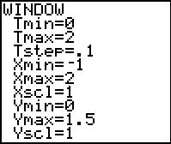
Then, in Function mode, students are instructed to use the Trace feature. Press  and use  and  to explore the graph. Ordered pairs will appear that represent a time in seconds and the height of the pancake above the griddle at that time. Students will record several ordered pairs (round to the nearest tenth) in the table on the student worksheet. | 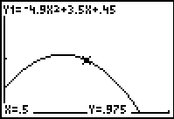
Next, students will use maximum feature (  ) to find the maximum height of the pancake, and when it occurs. The maximum feature will give the ordered pair for the maximum. Students will be asked for a left bound (move to the left of the maximum and press ), a right bound (move to the right of the maximum and press ), and a guess (move near the maximum and press ).
Students will also discover the time at which the pancake lands on the hot griddle. The will use the zero feature (  ). This is the solution.

Homework Problem – Soccer Ball
A new scenario is presented as an application of parabolas. This time, the height of the object is measured in feet since it is a ball, and time is still measured in seconds. Students should be able to complete this problem for homework or as a more self-directed activity this time. | 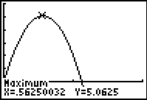
Students will repeat the procedure from Problem 3 by graphing the equation, using , maximum, and zero to answer a series of questions. | 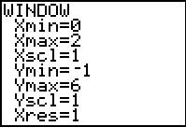
The question is asking for whether the maximum height exceeds the height of the top of the goal. Then students must consider other types of situations that might produce a quadratic parabola for its graph. In other words, where does gravity come into play?
Reminder, this graph does NOT represent the path of the ball as it travels toward the goal. Therefore, we do not actually know if the ball will go into the goal, over the goal, or even fly off course to the side of the goal. (horizontal distance traveled is a different equation)

Extensions
Two different equations were introduced that actually have the effect of “gravity” built into them. In the pancake problem, the equation contains –4.9x², and in the soccer problem, the equation contains –16x². Investigate why there are two different numbers used in these equations. If needed, students can search for information about “acceleration due to gravity” on the internet in order to answer.
Students will explain the entire formula for projectile motion: h(t) = –0.5gt² + v₀t + h₀. They should use answers to previous questions to help to explain the variable “g” in the formula.
Finally, students should write their own projectile motion problem using g = 32, initial velocity = 28 ft/sec, and an initial height = 3 ft.

