Activity Overview
In this activity, you will construct a minimized slider in the Graphs application that will allow you to graph the function for 0 ≤ a ≤ 4.

Materials
- Technology needed (TI-Nspire™ handheld, computer software)

Steps

Step 1: Creating a title page  1. Press c > New Doc > Add Notes.  2. Create the title page by typing Graph Logarithms. | 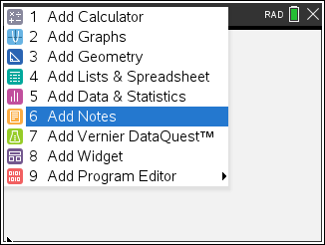
Step 2: Preparing the document  1. Press / I > Add Graphs. | 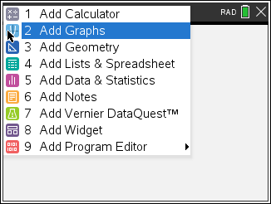
Step 3: Inserting a slider  1. Press Menu > Actions > Insert Slider.  2. Move slider to top left corner.  3. Hover your cursor over the slider box and press / b. | 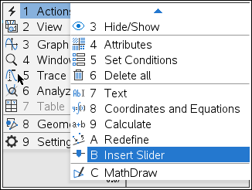
3. Choose Settings. Move through the fields by pressing e. Change the values so that: Variable = a, Value =2, Minimum = 0, Maximum = 4, Step Size = 0.1, Style = Vertical, and Display Digits = Fix 2. Click on the check box for minimized.  4. Press · when complete. | 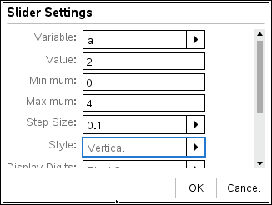
Step 4: Entering the function  1. Press / G to show the function line if necessary or e to make entry line active.  2. Press t.  3. On the top row, choose the expression for logarithm and enter .  4. Press ·.  5. Move the cursor to the graph of the function and then press / b > Attributes.  6. Arrow to the right and change the line width of the graph to medium. Press x. | 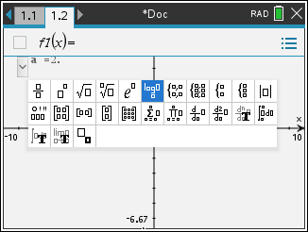  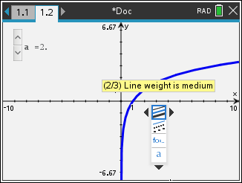
Step 5: Adjusting the window  1. Press Menu > Window/Zoom > Window Settings.  2. Move through the fields by pressing e. Change the values so that: XMin = –5, XMax = 20, XScale = 1, YMin = –10,  YMax = 10, and YScale = 1. Press · when complete. | 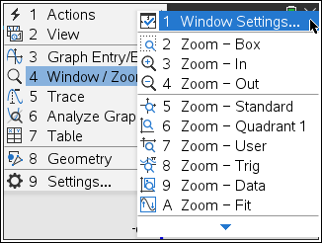  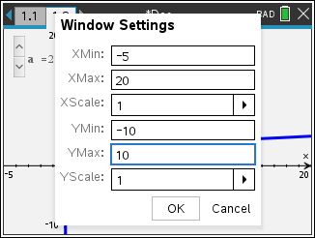
Step 6: Labeling the x-intercept  1. Press Menu > Trace > Graph Trace.  2. Use ¡ or ¢ to move to the point (1, 0) and then press ·. (Note: Before pressing ·, if you are not at that point, you may also press 1 ·, and the cursor will automatically move to that point.)  3. Press d. | 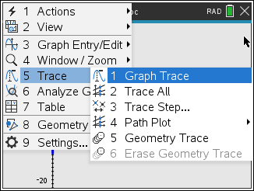  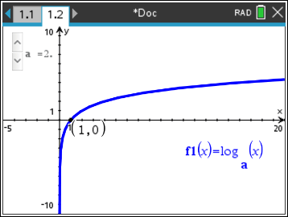
Step 7: Labeling another important point  1. Press Menu > Actions > Text.  2. Click anywhere in the lower part of the screen.  3. Type a in the text box. Press ·. This will be the variable a.  4. Press d.  5. Press Menu > Actions > Calculate.  6. Select the variable a by clicking the letter a.  7. Press L to link the variable a to the slider a. A faint 2 will appear. Press · to secure this value to the page.  8. Press d.  9. Press Menu > Geometry > Construction > Measurement transfer.  10. Select the a-value, which is currently 2, and then select the  x-axis. The point (2, 0) should appear.  11. Press d.  12. Press Menu > Geometry > Construction > Perpendicular.  13. Select the point (2, 0) and the x-axis.  14. Press d.  15. Press Menu > Geometry > Points & Lines > Intersection Point(s).  16. Select the graph of the function and the perpendicular line. Press P to label the point. (You may have to move the label for point P to a convenient location by grabbing it.)  17. Press d.  18. Press Menu > Actions > Coordinates and Equations.  19. Select the point of intersection. This should be the point (2, 1). (Note: You may have to press e to select the point (2, 1) instead of (2, 0).) Press · to secure this point to the page.  20. Press d.  21. Press Menu > Actions > Hide/Show.  22. Your cursor will turn to ú. Use this new cursor to select the perpendicular line, the point (2, 0), the variable a, and the value of the variable a. This will hide, not delete, these items from the screen. (Note: You may have to press e to select the point  (2, 0) instead of (2, 1).) Exit the Hide/Show tool by pressing d.  23. Your final page should look the one in this figure. | 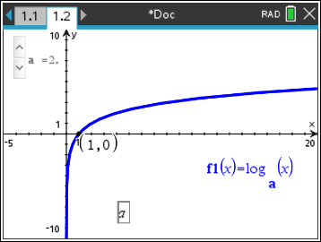  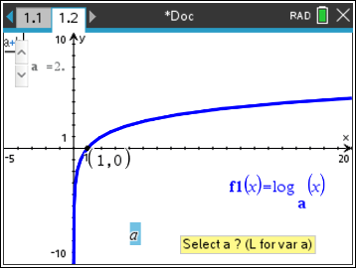  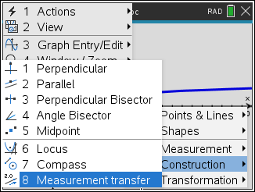  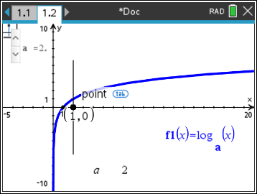  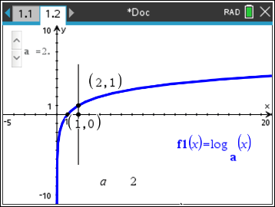  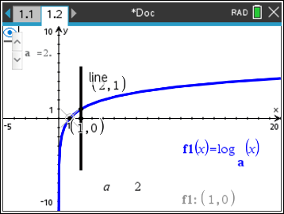  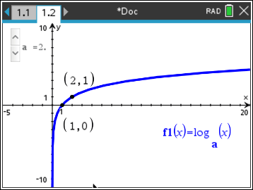
Step 8: Saving the document
1. Press ~ > File > Save As.
2. Save in suggested folder and use the file name Graph_Logarithms.

