Open the TI-Nspire document Enzyme_Catalysts.tns.  In this activity, you will:  - Describe the difference between anabolism and catabolism.  - Identify factors that affect the rate of chemical reactions. | 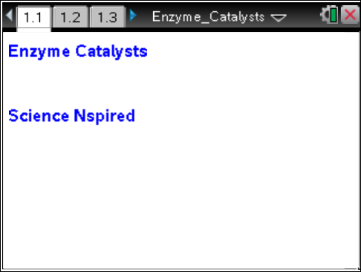
Enzymes are very important biological molecules. Enzymes help speed up reactions in and around cells. Many enzymes are known as anabolic enzymes, and these build larger molecules from smaller ones. Others are catabolic, which break down larger molecules into smaller ones. You produce hundreds of different enzymes in your cells, all of which facilitate some chemical reaction in the body.
Here’s an example: Hydrogen peroxide (H₂O₂) is produced naturally inside many of your cells. The trouble is that it is very toxic to us. To deal with this, we produce an enzyme called catalase, which serves to break down hydrogen peroxide into a couple of pretty harmless substances:
2H₂O₂ → 2H₂O + O₂
Let’s discuss some things about enzymes for a minute. Enzymes are globular proteins that are responsible for most of the chemical activities of living organisms. They act as catalysts—substances that speed up chemical reactions without being destroyed or changed during the process. Enzymes are very efficient, and they can be used over and over again. One enzyme may very well catalyze hundreds, or even thousands, of reactions every second!
Enzymes, however, can be temperamental. Most enzymes are very picky about the situations in which they will work. Temperature and pH are very important factors. If the environment is too hot or too cold, or too acidic or too basic, the enzyme may not catalyze its reaction at all. In fact, if the conditions are too extreme, the enzyme may quit working altogether because its structure may become distorted. In these cases, we say that the enzyme has become denatured.
Have you seen the bubbles that form when you place hydrogen peroxide (H₂O₂) on a cut? This is a reaction between hydrogen peroxide and catalase? Where is catalase found in living organisms? There is a fair amount of catalase in blood! In addition, it can be found in many different tissues in both plants and animals.
In this experiment, you will measure the rate of enzyme (catalase) activity under various conditions. To do this, you will measure the pressure of oxygen gas in a flask as it is released during the chemical reaction between hydrogen peroxide and catalase.

Problem 1 – Preliminary Questions
Move to page 1.2.
1. Read the introduction on page 1.2. |  |  |  |  |  | 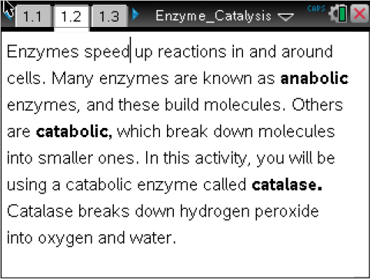
Move to pages 1.3–1.7. Answer the following questions here or in the .tns file. |  |  |  |  |  | 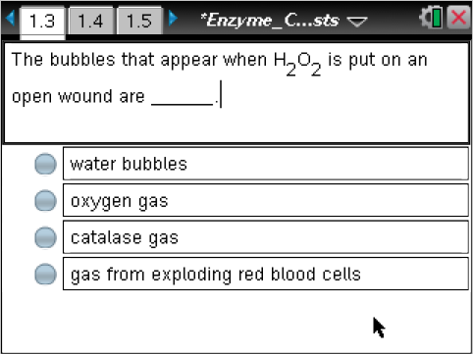
Q1. The bubbles that appear when H₂O₂ is put on an open wound are ____________.
A. water bubbles  B. oxygen gas |  |  | C. catalase gas  D. gas from exploding red blood cells
Q2. Why do you think hydrogen peroxide is stored in a brown bottle?
A. Because it is photosensitive. | B. To prevent it from being destroyed by catalase. |  |  |  | C. People prefer to buy chemicals in brown bottles.
Q3. The following reaction would be anabolic: A + B → AB
A. True |  |  | B. False
Q4. The process of cellular respiration, which is breaking glucose into water and carbon dioxide, would be a (an) ____________ reaction.
A. anabolic |  |  | B. catabolic
Q5. Photosynthesis, which builds glucose from CO₂ and H₂O, would be a (an) ____________ reaction.
A. anabolic |  |  | B. catabolic
Problem 2 – Reaction Rate Data Collection
Move to page 2.1.  2. Page 2.1 is a blank DataQuest application. Connect the EasyLink to the TI-Nspire, and then connect the Gas Pressure Sensor to the EasyLink. Set the TI-Nspire to collect data every 1 second for 30 seconds.  3. Attach the tube to the pressure sensor, and then attach the black stopper to the tube.  4. Use the graduated cylinder to measure 5 mL of hydrogen peroxide and pour it into the flask. |  |  |  |  |  | 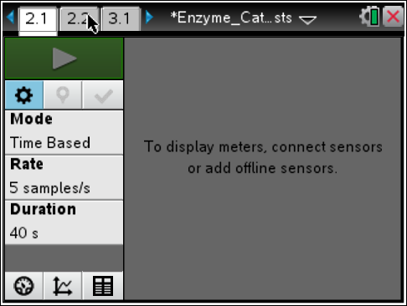
5. Draw 1 mL of the catalase suspension into the syringe.
6. Press Start Data Collection on the TI-Nspire, and immediately add the catalase suspension to the flask. Then, quickly put the stopper firmly in the mouth of the flask.
Move to page 2.2.  7. View the collected data in the Data & Statistics application on page 2.2. Use the Entry Line to set the x-axis to the variable run1.time and the y-axis to run1.pressure. Use the Moveable Line tool (Menu > Analyze > Add Moveable Line) to fit a line to the collected data. Be sure to fit the line to the data collected during the initial phase of the chemical reaction. |  |  |  |  |  | 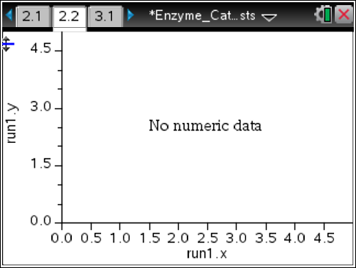
Move to page 3.2.  8. Observe the slope of the fitted line to determine the rate at which the pressure of the gas changes. Record these data in the Lists & Spreadsheets application on page 3.2. |  |  |  |  |  | 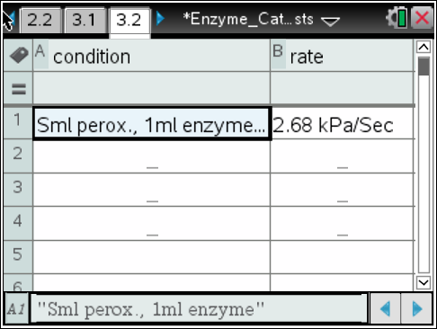
Problem 3 – Manipulation of Reaction Variable
9. Modify a variable from the investigation in Problem 2. You may want to modify any of the following variables:
• Amount of hydrogen peroxide in the flask
• Amount of enzyme added to the flask
• Temperature of flask (placed in hot or cold water)
• Type of enzyme used (use “boiled” enzyme instead)
10. Repeat the experiment from Problem 2 with a modified variable and view the collected data on page 2.1. Be sure to rinse and dry the reaction flask between experiments.
11. For each set of newly collected data, determine the rate of reaction and record it on page 3.2.
Problem 4 – Analysis
Move to pages 4.1–4.10. Answer the following questions here or in the .tns file.
Q6. Catalase is an enzyme; it is also a protein. What are the monomers of proteins?
A. amino acids  B. monosaccharides |  |  |  | C. triglycerides  D. nucleotides
Q7. Since catalase is a protein, where in the cell is it probably made?
A. in the nucleus  B. in the chloroplasts |  |  |  | C. on the surface of the Golgi bodies  D. on ribosomes
Q8. Because catalase is a protein, where are the instructional blueprints for making catalase?
A. on the plasma membrane  B. in the DNA in the nucleus |  |  |  | C. on the RNA  D. in the cytoplasm
Q9. In this activity, hydrogen peroxide was the catalyst that was used to speed up the reaction.
A. True |  |  |  | B. False
Q10. When you used boiled catalase, you probably noticed a very slow reaction rate. Predict why this happened.

Q11. Which trial should have had the fastest rate of reaction? The trial using the flask that had ________.
A. room temperature catalase  B. boiled catalase |  |  |  | C. catalase on ice  D. catalase in warm water
Q12. What was the result of increasing the amount of catalase used?

Q13. What was the result of decreasing the amount of catalase used?

Q14. What graphical evidence is there to suggest that the rate of the reaction did not stay constant throughout the data collection?

Q15. As a variation of the experiment you could increase the amount of catalase but keep the amount of peroxide the same. How would the final pressure in the flask compare to that of the initial experiment (the control)?
A. It would be higher. |  | B. It would be lower. |  |  |  | C. It would be at the same level.

