Open the TI-Nspire document Exploring_Exponents.tns.  In this activity, you will investigate what happens as you increase or decrease exponents in two expression. You will explore how the numerical calculation of 2^{–4} relates to 2⁴. You will learn what the negative integer exponent means. | 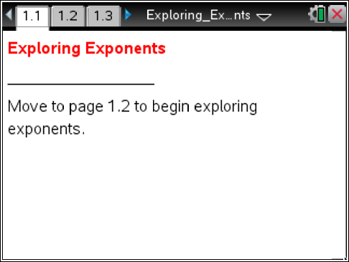

Move to page 1.2.
1. What is the numerical value of 2⁴? Describe how you determined this value.

Move to page 1.3.
2. Use the arrows to increase or decrease the exponents on 2^{x} and 3^{x}. Describe what you see happening to the values in the equations.

3. As you increase (or decrease) the exponents, look for a pattern between the exponents and the values in the equations to help you explain why the values in the equations change as they do.

Complete this table. What patterns do you notice?

x | 2^{x} | 3^{x}
3
2
1
0
-1
-2

4. Use your reasoning from question #3 to help explain why 2⁰ = 1 and 3⁰ = 1.

5. What do you notice about the values in the equations when the exponents are negative?

6. James says that 4^{–2} = –16. Kayley says that 4^{–2} = –1/16. With whom do you agree and why?

7. What is the value of 2 ^{–11}? Would 2 ^{–12} be greater or less than 2 ^{–11}? Explain your reasoning.

