Open the TI-Nspire document Particle_Motion_2.tns.  This activity models the motion of a particle along a straight, horizontal line. You will examine the relationship between the position of the particle, the velocity of the particle, and the cumulative distance traveled by the particle. | 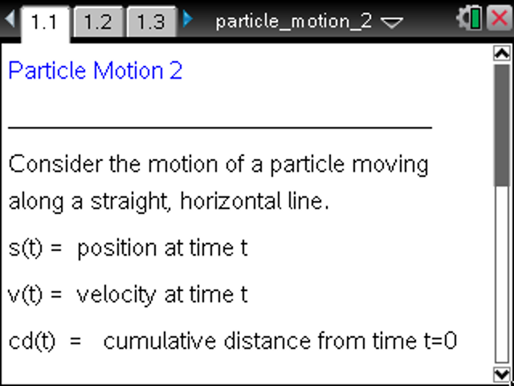

Move to page 1.2. | Press / ¢ and / ¡ to navigate through the lesson.
- For measured in seconds, is the position of the particle at time , is the velocity of the particle at time , and is the cumulative distance traveled by the particle from time
- The values of , , and are given in the left panel on Page 1.3 and Page 1.4.
- Use the clicker arrows to change the value of . On Page 1.3, you can also grab and move the open circle on the horizontal axis to change the value of .
- The position graph is displayed on page 1.3, and the velocity graph is shown on page 1.4.
- The motion of the particle is modeled in the top panel on both pages.
- The function can be redefined on page 1.2.
Move to page 1.3.

1. Use the clicker arrows to change the value of You can also drag the position slider (the open circle) attached to the horizontal axis (the -axis) to change the value of Observe the position of the particle, the cumulative distance traveled, and the velocity of the particle.
a. Describe the behavior of the position graph when the particle is moving to the right.

b. Describe the behavior of the position graph when the particle is moving to the left.

c. Describe the behavior of the position graph when the particle changes directions.

2. Compare the graph of the position function on page 1.3 and the graph of the velocity function on page 1.4.
a. As increases from 0 to approximately 1.6, describe how the steepness changes in the position graph and how the magnitude of the velocity changes.

b. As increases from approximately 1.6 to 4.7, describe how the steepness changes in the position graph and how the magnitude of the velocity changes.

c. Consider values for greater than 4.7, and compare the steepness of the position graph and the relationship to the velocity. Make a general conjecture about the steepness of the position graph and the velocity function.

Move to page 1.4.

3. Use the clicker arrows to change the value of On page 1.4, you cannot grab and move the point on the horizontal axis. The shaded part of this graph is the region bounded by the velocity graph the horizontal axis, and the vertical lines at 0 and In the left panel, the total area is the area of all shaded regions. The signed area is the sum of all the areas above the horizontal axis minus the areas below the horizontal axis.
a. Compare the signed area (computed and displayed in the left panel) and the position of the particle.

b. Compare the cumulative distance traveled and the total area (computed and displayed in the left panel) of the shaded region.

4. On page 1.2, reset the time to 0, and define the position function to be To define the position function on page 1.2, use the calculator command Define or by using “:=” (the assignment characters). For example,
a. Use the resulting graph of the position function on page 1.3 to describe the motion of the particle, the velocity, and the total distance traveled over the time interval

b. Why is the position equal to the cumulative distance over the interval

5. On page 1.2, reset the time to 0, and define the position function to be
a. Use the resulting graph of the position function on page 1.3 to describe the motion of the particle, the velocity, and the total distance traveled.

b. How would you use the area of the shaded region on page 1.4 to compute the position of the particle at any time?

6. On page 1.2, reset the time to 0. In each part below, try to define a position function that satisfies the given properties over the time interval
a. The position of the particle is 0 at times , and

b. The position of the particle is at time The particle has positive velocity until time and negative velocity after time

c. The position of the particle is at time The position of the particle oscillates about 0, but with smaller oscillations as time goes on.

This page intentionally left blank.

