Open the TI-Nspire document Team_Effort.tns.  When you are sitting in the cafeteria eating that "delicious" school lunch, have you ever wondered what happens to that slice of pepperoni pizza you just ate? Probably not! But hopefully after you complete this activity, you will know how the organs inside you have specific jobs to make sure your food gets broken down to give you nourishment and energy. | 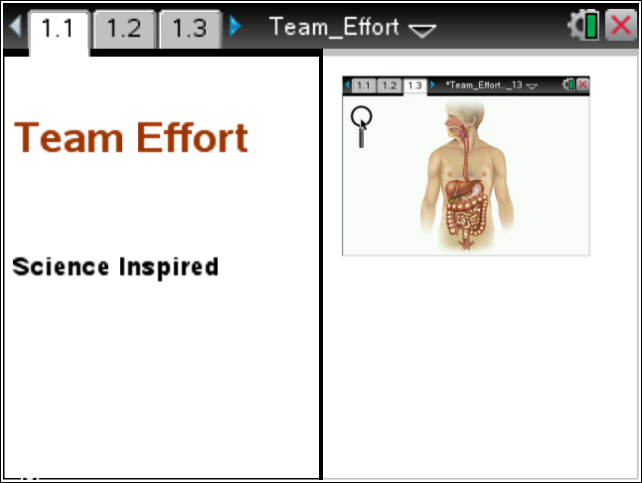
Move to page 1.2. Read the background information for the activity.

Your digestive system is an amazing group of organs that work as a team. Each organ is made up of tissues, which are made up of cells. These cells are not just any kind of cells. In fact, they are specialized cells that give the tissues the right structure. This allows the organ can carry out the right function. For example, special cells make up the stratified squamous epithelium tissue that lines your mouth organ.

Move to page 1.3.
Read the instructions for the simulation.

1. Select and drag the magnifying glass across the diagram of the human body until a question mark “hot spot” appears.  2. Select the hot spot and read the information that appears. Record the information in the table below.  3. Repeat step 2 until you have filled in all of the cells on the table. | 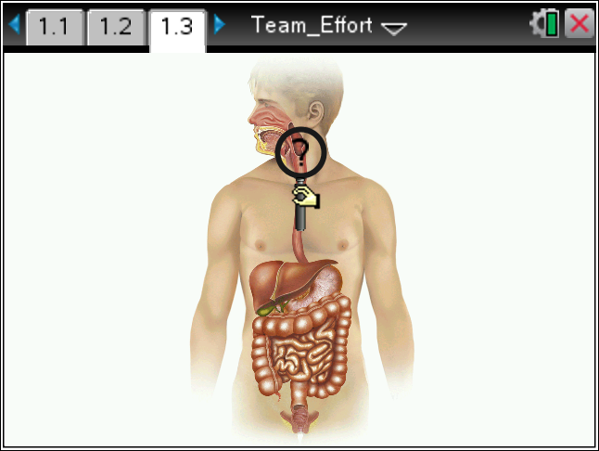
Tech Tip: To access the Directions again, select b or Document Tools () > Team Effort > Directions.
Tech Tip: To access the Directions again, select > Team Effort > Directions.
Digestive Organ | Tissue Type | Function
Mouth
Pharynx and Upper ½ of Esophagus
Bottom ½ of Esophagus
Stomach
Small Intestine

Move to pages 1.4 – 1.10. Answer the questions here or in the .tns file.
Q1. What tissue type forms the lining of the mouth?
- skeletal muscle
- smooth muscle
- stratified squamous epithelium

Q2. Stratified squamous epithelium means
- layers of flat cells outer layer
- single layer of flat cells outer layer
- layers of square cells inner layer

Q3. How do you think the structure of the mouth lining relates to its function?

Q4. What tissue type helps you chew and swallow your food?
- smooth muscle
- stratified squamous epithelium
- skeletal muscle

Q5. What tissue type pushes your food down the esophagus to your stomach?
- skeletal muscle
- stratified squamous epithelium
- smooth muscle

Q6. What tissue type in your stomach adds juices to chemically break down your food?
- smooth muscle
- simple columnar epithelium
- skeletal muscle

Q7. What is the function of the microvilli that line the small intestine?
- sweep the digested food to the large intestine
- absorb nutrients into the blood
- add more chemicals to the food

