Open or create the TI-Nspire document Triangle_Midsegments.tns.  In this activity, you will collect length and area data from a triangle and one of its midsegments. You will investigate relationships for the measurement data with a spreadsheet. | 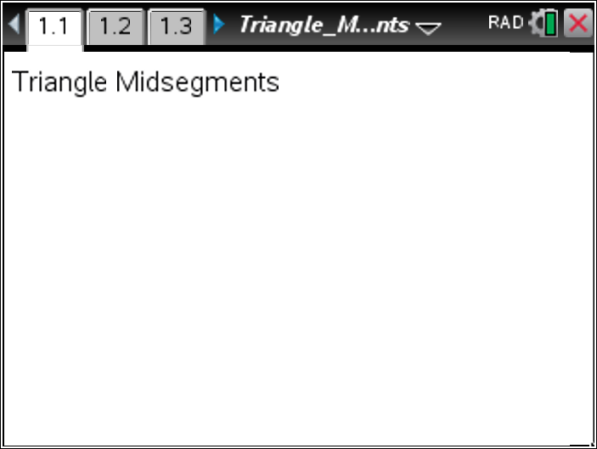

Move to page 1.2.

Part 1—Finding the ratio of the side to the segment  A midsegment is a segment connecting the midpoints of two sides of a triangle.  Page 1.2 shows ∆ABC with midsegment parallel to side . MN and BC have been defined as variables.  - What can you say about the relationship between ∆ABC and ∆AMN? How do you know? | 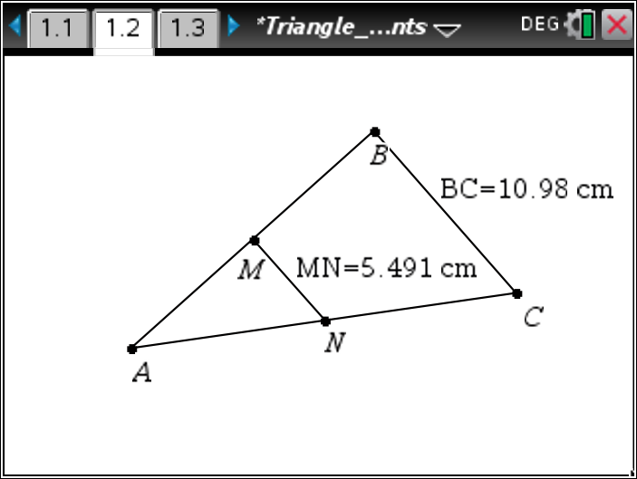
You will capture these segment measurements into the spreadsheet on page 1.3. Drag point B or point C to form a new triangle. Press / ^. This captures the current lengths for and .  Press / ¢ to look at the spreadsheet. The measurements appear in rows.  Return to page 1.2. Drag point B or point C to form another triangle. Press / ^. Repeat four more times.  Return to page 1.3. Examine the data in Columns A and B. | 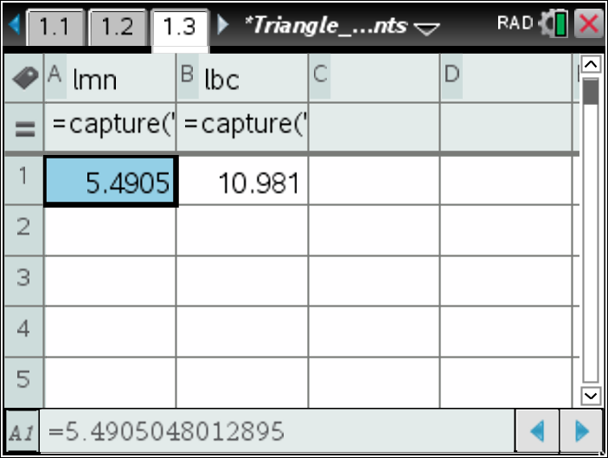
- What comparison can you make between the two columns?  Move your cursor to the top of Column C (above the diamond row). Name this column lratio and press ·.  In the diamond row, enter a formula using the column names for Columns A and B. To do this, move your cursor to the diamond row of Column C and press x. Press h and select lbc from the list. Press p. Press h and select lmn from the list. Press ·.  Press · again.  - What does the formula mean?  - What does the result of the formula tell you about side and the midsegment ? | 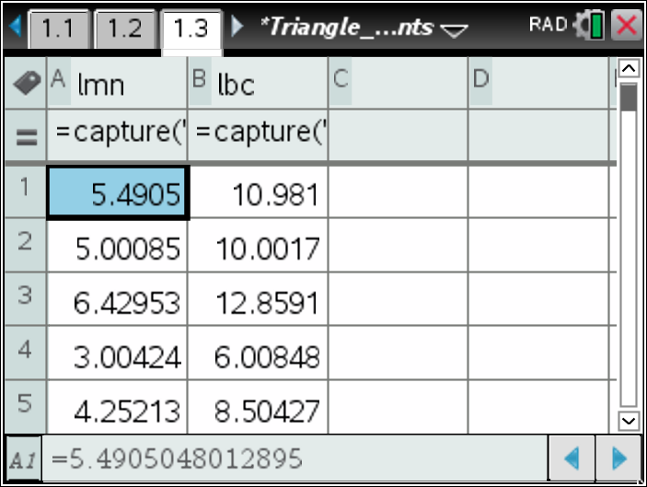  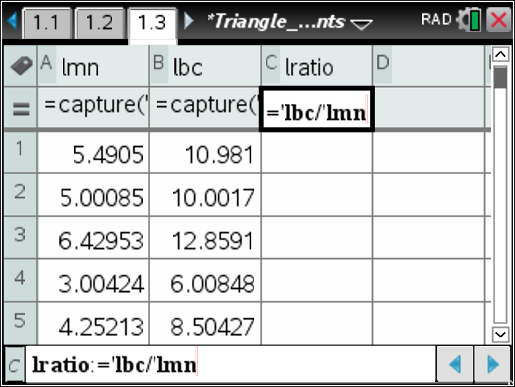
Part 2—Finding the ratio of the areas  Draw ∆AMN. To do this, return to page 1.2. Press Menu > Shapes > Triangle. Click on each of the points A, M, and N. Press d to exit the Triangle tool.  - What do you predict the ratio of the areas of ∆ABC and ∆AMN to be? | 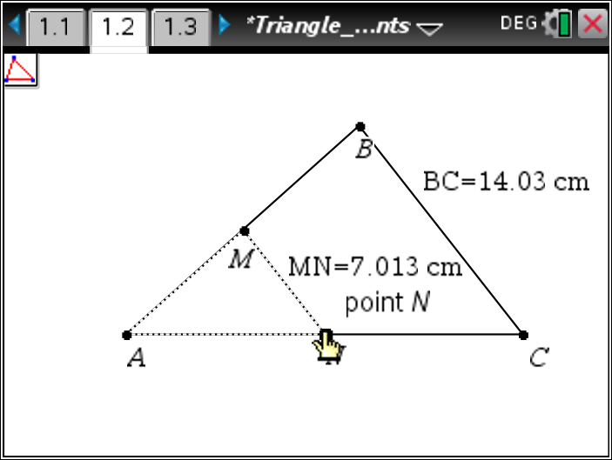
Measure the areas of ∆AMN and ∆ABC. To do this, press Menu > Measurement > Area. Click on ∆AMN by hovering over . Move the measurement to a clear area of the screen and click to drop it. Repeat to measure ∆ABC. Press d to exit. | 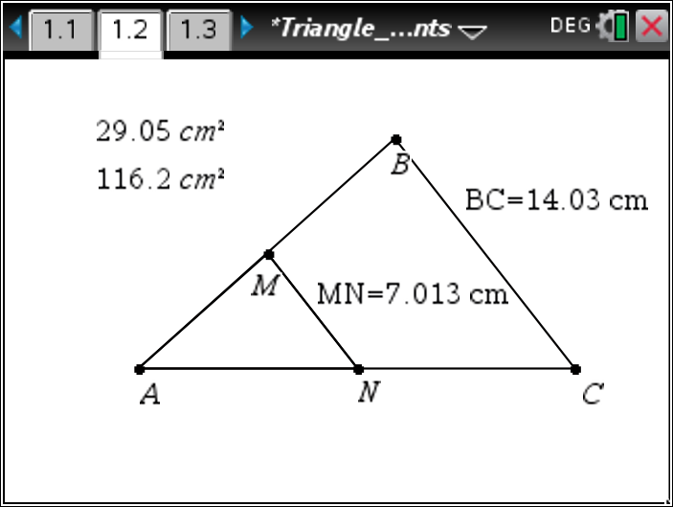
Define each area measure as a variable. To do this, move your cursor to the measurement for ∆ABC. Click once. Press / h. Then type aabc and press ·. Repeat for ∆AMN, naming the variable aamn. | 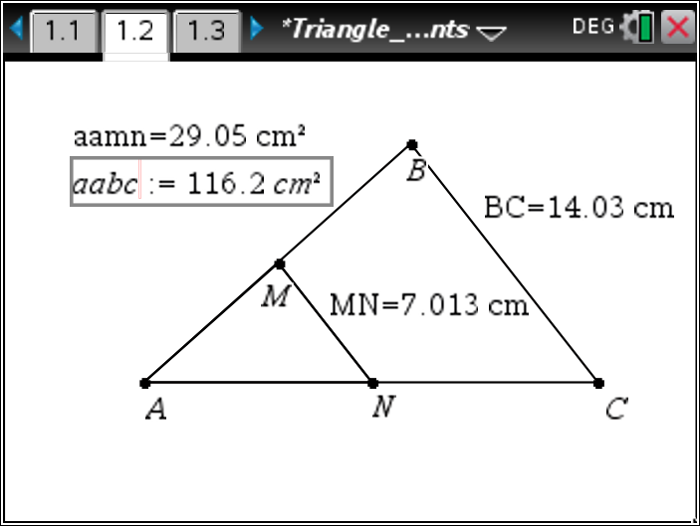
To analyze the ratio of the areas, capture some of the areas to the spreadsheet. To do this, move to page 1.3. Move your cursor to the top of Column D and name the column abc. Name Column E amn.  Move your cursor to the diamond row of Column D. Press Menu > Data > Data Capture > Automated Data Capture. Enter the variable aabc (by typing or by using the h key as in column C). Press ·. Repeat to define Column E to capture the area of ∆AMN.  Return to page 1.2. Drag point B or point C for a few seconds. The spreadsheet is rapidly capturing data as you drag.  Return to page 1.3. Use Column F to determine the ratios of the areas. Name Column F aratio using a procedure similar to lratio.  - Give and explain a ratio that describes the relationships between the areas of ∆ABC and ∆AMN.  - What is the ratio of the perimeters of the two triangles? How do you know? | 