Activity Overview:

In this activity, you will construct a minimized slider in the Graphs application to explore the function
f(x) = b^{x} for 0 ≤ b ≤ 4.

Steps

Step 1: Creating a title page
1. Press c and choose New Doc. Select Add Notes.

2. Create the title page by typing Graphing Exponential Functions.

Step 2: Inserting a Graphs page
1. Press / I or / ~ to insert a new page. Select Add Graphs.

Step 3: Inserting a slider  1. Press b and select Actions > Insert Slider.  2. Use your Touchpad to place the slider in the top left of the screen, press ·, then press B and then press ·. | 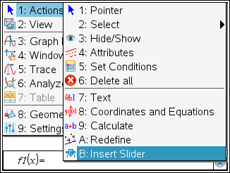
Step 4: Changing the slider settings
1. With the cursor over the slider box, press / b for the context menu.
2. Select Settings. Press e to move through the Slider Settings fields. Change the settings to:
Value: 2, Minimum: 0, Maximum: 4, Step Size: 0.25,
Style: Vertical, and Display Digits: Float 3.
3. When finished, press ·.
Step 5: Entering the function
1. Press / G to display the entry line (if hidden)
2. Type B l X.
3. Press ·.

4. Move the cursor over the graph of the function and press / b. Select Attributes.
5. Arrow to the right to select Line weight is medium.
6. Press ·.

Step 6: Adjusting the window  1. Press b and select Window/Zoom > Window Settings.  2. Move through the fields by pressing e. Change the values to:  XMin: –3, XMax: 3, XScale: Auto, YMin: –5, YMax: 20, and YScale:Auto.  3. When finished, press ·. | 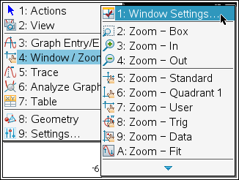
Step 7: Labeling points
1. Press Menu > Geometry > Points & Lines > Point On.
2. Move to the graph and press · to select the graph and then again to place the point. Press d. To move to the point (0, 1), double-click on the x-value, enter 0, and then the point will move.
3. Move the cursor to the point and press / b. Select Attributes.
4. Arrow to the right to select Large.
5. Press ·.
6. Repeat and place another point on the graph. Double-click on the x-value, enter 1, and then the point will move to (1, b).

Step 8: Changing the value of b
- Move the cursor over the slider controller. Press / x to close the hand and grab the slider controller.
- Use the Touchpad to move the slider controller and change the value of b.

Step 9: Saving the document
1. If desired, save the document. Press / S or / » to open the Save As dialog box. Enter a name and select a folder in which to save the document. Press ·.

