In this lesson you will look at a scenario of renting a video game system. You are going to rent a video system for $0.25 per hour plus $1.50 as a surcharge.
Part 1 – Number Sentences
1. If you rent the system above for 4 hours, how much will you pay? Show the number sentence you used.
You can enter the number sentence on the TI-84 Plus to perform the calculation. For 4 hours, you would press 0 . 2 5 * 4 + 1 . 5 0. Press e to display the result. | 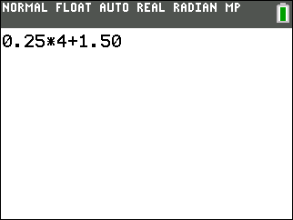
2. What if you rented the system for 6 hours? For 8 hours? Write the number sentence for each case.
3. Which part of your number sentence keeps changing? What does it represent?

4. How could you write a math sentence about this problem using the letter x to hold the place for the number of hours?
5. Is the number of hours the only thing that changes? If not, what else changes?

6. Now, write a math sentence using y to hold the place of the total cost.

Part 2 – Creating a Graph
Now, let’s enter several x- and y-values into lists to create a scatter plot.
7. Enter the x-values in L1 and the y-values in L2 for x-values of 1, 2, 3, 4, 5, and 10. List the ordered pairs. | 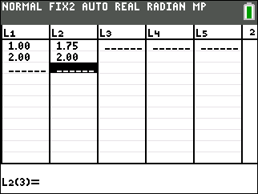
8. Set up a scatter plot as shown at the right. Then press % and draw the scatter plot you create of all the ordered pairs.  9. Draw a line to connect all the ordered pairs. What does this line represent? | 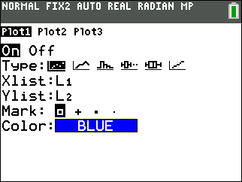  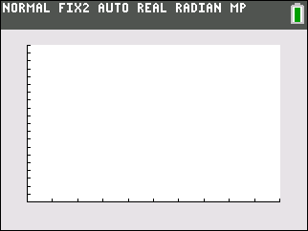
Part 3 – Change That Shape
Finally, look at the equation that can model our rental scenario.
10. Enter the math sentence you wrote in Question 6 into Y1 (press !), and then graph (press %). How does the graph of the equation compare to the line drawn in Question 9?

11. Look at a table of the function values. Press ` ç and set up the table as shown at the right. Press ` ê to see the actual table of function values. How do these values compare to the list of ordered pairs from Question 7? | 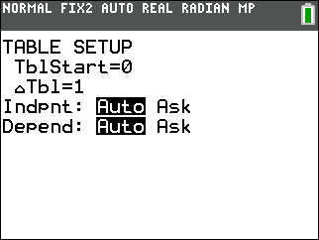
12. Use the Trace feature to trace both the scatter plot and the function. Use the words continuous and discrete to describe the differences between the two.

