Open the TI-Nspire document Absolute_Value.tns.  The purpose of this activity is to examine the family of absolute value functions of the form f(x) = a|x + c| + b, where a, b, and c are parameters. Use sliders in the left panel of each page to change the value of a parameter, and record the effect of each parameter on the graph of y = f(x). At the end of this activity, use your results to match each function with its corresponding graph. | 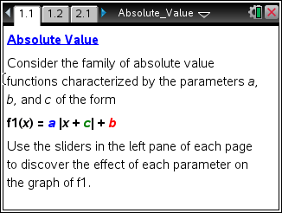

Move to page 1.2.

1. The graph of y = f1(x) = a • |x| is shown in the right panel. Describe the graph of y = |x|. Grab and move the slider in the left panel, and observe the changes in the graph of f1. Describe the effect of the parameter on the graph of y = a • |x|.

Move to page 2.1.

2. The graph of y = f1(x) = a|x| + b is shown in the right panel. Grab and move the slider for a to confirm your results in question 1. Grab and move the slider for b,, and observe the changes in the graph of f1. Describe the effect of the parameter b on the graph of y = a|x| + b.

Move to page 3.1.

3. The graph of y = f1(x) = a|x + c| + b is shown in the right panel. Grab and move the slider for a to confirm your results in question 1. Grab and move the slider for b to confirm your results in question 2. Grab and move the slider for c, and observe the changes in the graph of f1. Describe the effect of the parameter c on the graph of y = a|x + c| + b.

4. Match each equation with its corresponding graph.

(a) f(x) = –|x + 2| + 3 (b) f(x) = |x – 5| – 4

(c) f(x) = 0.5|x – 4| (d) f(x) = –2|x| + 5

(e) f(x) = –2|x – 3| – 1 (f) f(x) = –0.25|x + 4|

(i) | 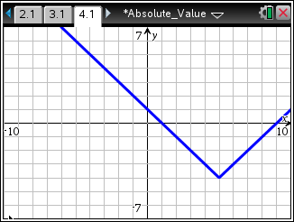 | (ii) | 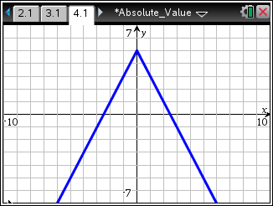
(iii) | 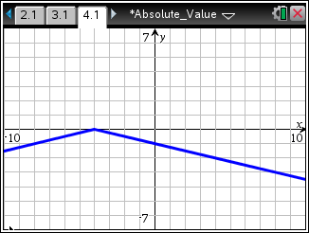 | (iv) | 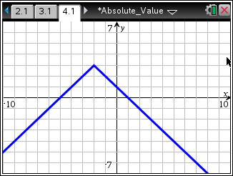
(v) | 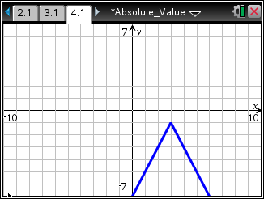 | (vi) | 