Problem 1 – Arranging Letters
Would you believe there are over 20 different arrangements of the letters A, B, C and D, when selecting three of the four letters? Record all the arrangements you can below.
Note: Each arrangement of letters should be different than the previous arrangement. For example, ABC is different than BCA.

Each of these arrangements is known as a permutation. To find permutations of a set, objects are arranged in a way such that the order of the objects matters.
The notation for permutations is _{n}P_{r}, where n is the total number of objects and r is the number of objects selected. You can use the following formula to find the total number of permutations:
Use this formula to find out how many ways you can select 3 letters from 4 letters when the order matters.
Using n = 4 and r = 3, press  , select ! from the PRB menu.  Next press       , select PRB and choose !.  Press  to observe the answer. | 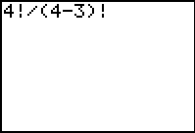
To arrive at this answer much quicker, use the built-in nPr function of the graphing calculator.  To do this, press  , select 2:nPr from the PRB menu, and then press . | 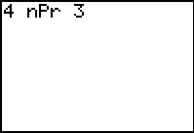
Do these values match the number of arrangements you found above earlier?

Problem 2 – Arranging Letters in a Different Way
Now, let’s arrange the letters in the same way, but this time the order of the letters does not matter. Record all the arrangements you can below.
For example, ABC is not different than BCA.

Each of these arrangements is known as a combination. To find combinations of a set, objects are arranged in a way such that the order of the objects does not matter.
The notation for permutations is _{n}C_{r}, where n is the total number of objects and r is the number of objects selected. You can use the following formula to find the total number of permutations:
Use this formula to find out how many ways you can select 3 letters from 4 letters when the order does not matter.
Using n = 4 and r = 3, match the calculator screen to the right. Press  to observe the answer. | 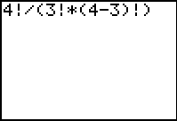
To arrive at this answer much quicker, use the built-in nCr function of the graphing calculator.  To do this, press  , select 3:nCr from the PRB menu, and then press . | 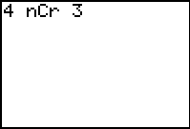
Does this match the number of arrangements you found earlier?

Problem 3 – Permutation versus Combination
Answer the following questions.
- Selecting five cards from a standard deck of cards is an example of a combination.
True or false?

- Selecting three letters for a license plate is an example of a combination.
True or false?

- Which expression has a larger value, ₅C₃ or ₅P₃?

- Why are there more arrangements when calculating a permutation than a combination?

Extension – Handshake Problem
Suppose each person in a group shakes hands with every other person in the group. How many handshakes occur?
On the pictures below, connect pairs of points (representing people) with a segment until all points are connected to each of the other points. The number of segments equals the number of handshakes. Record your results in the chart.

People
n | 2 | 3 | 4 | 5 | 6
Number of Handshakes

- Is this situation a combination or permutation? Why?

- How many handshakes occur if there are n people?

